14. Scenario: You are a data analyst working for a company that sells products online. You have

been tasked with analyzing the sales data for the past month. The data is stored in a Pandas data

frame.

Question: Develop a code in python to find the frequency distribution of the ages of the customers

who have made a purchase in the past month.

Code:

import pandas as pd

import matplotlib.pyplot as plt

df = pd.read_csv(r"C:\Users\jampa\Downloads\customer_age_distribution.csv")

age_counts = df['Age'].value_counts().sort_index()

print(age_counts)

# Optional: Plot the distribution

plt.figure(figsize=(12, 6))

age_counts.plot(kind='bar')

plt.title("Frequency Distribution of Customer Ages")

plt.xlabel("Age")

plt.ylabel("Frequency")

plt.grid(True)

plt.tight_layout()

plt.show()

output:

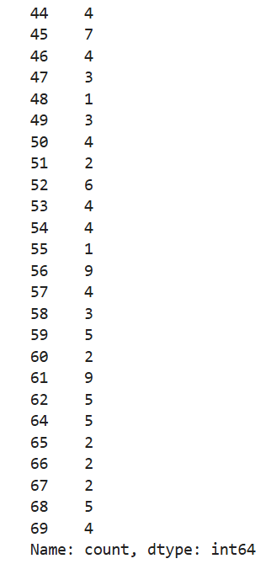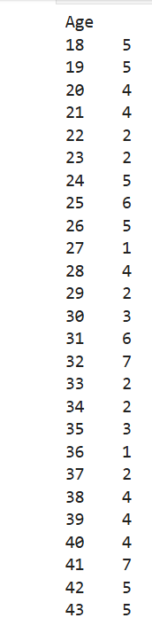

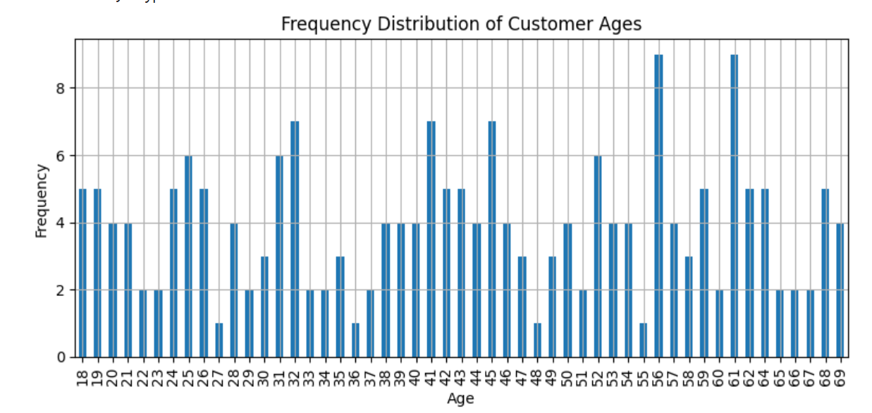

Dataset:

|  |  |
| --- | --- |
| CustomerID | Age |
| 1 | 56 |
| 2 | 69 |
| 3 | 46 |
| 4 | 32 |
| 5 | 60 |
| 6 | 25 |
| 7 | 38 |
| 8 | 56 |
| 9 | 36 |
| 10 | 40 |
| 11 | 28 |
| 12 | 28 |
| 13 | 41 |
| 14 | 53 |
| 15 | 57 |
| 16 | 41 |
| 17 | 20 |
| 18 | 39 |
| 19 | 19 |
| 20 | 41 |
| 21 | 61 |
| 22 | 47 |
| 23 | 55 |
| 24 | 19 |
| 25 | 38 |
| 26 | 50 |
| 27 | 29 |
| 28 | 39 |
| 29 | 61 |
| 30 | 42 |
| 31 | 66 |
| 32 | 44 |
| 33 | 59 |
| 34 | 45 |
| 35 | 33 |
| 36 | 32 |
| 37 | 64 |
| 38 | 68 |
| 39 | 61 |
| 40 | 69 |
| 41 | 20 |
| 42 | 54 |
| 43 | 68 |
| 44 | 24 |
| 45 | 38 |
| 46 | 26 |
| 47 | 56 |
| 48 | 35 |
| 49 | 21 |
| 50 | 42 |
| 51 | 31 |
| 52 | 67 |
| 53 | 26 |
| 54 | 43 |
| 55 | 19 |
| 56 | 37 |
| 57 | 45 |
| 58 | 64 |
| 59 | 24 |
| 60 | 61 |
| 61 | 25 |
| 62 | 64 |
| 63 | 52 |
| 64 | 31 |
| 65 | 34 |
| 66 | 53 |
| 67 | 67 |
| 68 | 57 |
| 69 | 21 |
| 70 | 19 |
| 71 | 23 |
| 72 | 59 |
| 73 | 21 |
| 74 | 46 |
| 75 | 35 |
| 76 | 43 |
| 77 | 61 |
| 78 | 51 |
| 79 | 27 |
| 80 | 53 |
| 81 | 31 |
| 82 | 48 |
| 83 | 65 |
| 84 | 32 |
| 85 | 25 |
| 86 | 31 |
| 87 | 40 |
| 88 | 57 |
| 89 | 38 |
| 90 | 33 |
| 91 | 62 |
| 92 | 35 |
| 93 | 64 |
| 94 | 41 |
| 95 | 43 |
| 96 | 42 |
| 97 | 62 |
| 98 | 58 |
| 99 | 46 |
| 100 | 32 |
| 101 | 62 |
| 102 | 18 |
| 103 | 42 |
| 104 | 24 |
| 105 | 26 |
| 106 | 41 |
| 107 | 18 |
| 108 | 61 |
| 109 | 25 |
| 110 | 41 |
| 111 | 28 |
| 112 | 68 |
| 113 | 34 |
| 114 | 25 |
| 115 | 52 |
| 116 | 52 |
| 117 | 50 |
| 118 | 22 |
| 119 | 59 |
| 120 | 56 |
| 121 | 58 |
| 122 | 45 |
| 123 | 24 |
| 124 | 26 |
| 125 | 25 |
| 126 | 29 |
| 127 | 51 |
| 128 | 50 |
| 129 | 65 |
| 130 | 40 |
| 131 | 41 |
| 132 | 54 |
| 133 | 52 |
| 134 | 61 |
| 135 | 57 |
| 136 | 39 |
| 137 | 44 |
| 138 | 52 |
| 139 | 18 |
| 140 | 52 |
| 141 | 54 |
| 142 | 64 |
| 143 | 31 |
| 144 | 20 |
| 145 | 18 |
| 146 | 22 |
| 147 | 43 |
| 148 | 31 |
| 149 | 56 |
| 150 | 44 |
| 151 | 26 |
| 152 | 32 |
| 153 | 32 |
| 154 | 43 |
| 155 | 59 |
| 156 | 30 |
| 157 | 68 |
| 158 | 49 |
| 159 | 56 |
| 160 | 66 |
| 161 | 69 |
| 162 | 49 |
| 163 | 21 |
| 164 | 47 |
| 165 | 54 |
| 166 | 40 |
| 167 | 56 |
| 168 | 62 |
| 169 | 32 |
| 170 | 60 |
| 171 | 46 |
| 172 | 53 |
| 173 | 30 |
| 174 | 49 |
| 175 | 24 |
| 176 | 68 |
| 177 | 39 |
| 178 | 45 |
| 179 | 19 |
| 180 | 59 |
| 181 | 62 |
| 182 | 23 |
| 183 | 45 |
| 184 | 45 |
| 185 | 61 |
| 186 | 61 |
| 187 | 37 |
| 188 | 47 |
| 189 | 28 |
| 190 | 45 |
| 191 | 42 |
| 192 | 56 |
| 193 | 50 |
| 194 | 18 |
| 195 | 44 |
| 196 | 69 |
| 197 | 30 |
| 198 | 58 |
| 199 | 20 |
| 200 | 56 |